Basic Transmission - SOLUTIONS

1
What is the period of
- a 1kHz signal? T=1/f; f=1kHz, T=1mS
- a 200 kHz signal = 5uS
- a 5MHz Signal = 0.2uS
note – for (iii) we could say 2 * 10⁻⁷ but units are usually kept as mS or uS

2
What is the relation between wavelength, frequency and velocity of propagation

V = f * λ ;
i.e. f = V/ λ
λ=V/f

3
What is self inductance, and how does it affect the transmission of a signal along a conductor?

Self inductance: the induction of a voltage in a current-carrying conductor when the current in the conductor itself is changing (e.g. a signal, alternating current, ect).
In the case of self-inductance, the magnetic field created by a changing current in the circuit itself induces a voltage in the same circuit.
i.e. the voltage is self-induced.

4
What other electrical characteristics affect the transmission of a signal in a long length of cable (transmission line)?

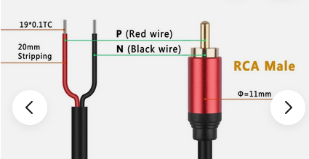

A cable (i.e. a fairly long connector, and consider it as having two conductors) will have -
inductance (L) along the length of the conductor
resistance (R) along the length of the conductor,
capacitance (C) between the conductors
and conductance (G) between the conductors
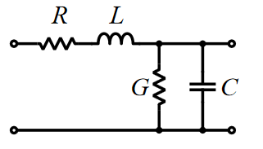
These are often considered as lumped parameters per unit length

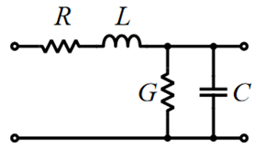






5
What is total internal reflection? How does it affect the propagation of light in a fibre?

… where an incident ray inside the fibre approaches the edge of the fibre at a sufficiently shallow angle causing the ray to be totally reflected within the fibre. (At a certain angle the ray will pass through the edge of the fibre and out of the cable).

6
If a pulse of white light source is shone into a fibre, how is the pulse affected as the pulse travels along the fibre?

It depends on the fibre!
Considerations – the ray splits into a number of rays, each travelling different paths, so different distances. The pulse therefore “spreads out” by the time these rays arrive at the receiver. If we have graded index fibre, we can mitigate these effects
There could also be a chromatic spread of the constituent colours (q.v. prism / diffraction) so different colours arrive at different times (typically shorter wavelengths (blue) travel faster than longer (red) wavelengths).

7
- What are the differences between propagation of a sound wave and a radio wave?
A sound wave is mechanical – its propagation relies on the molecules in the air passing the energy through from the source through the air (molecules hit neighbouring molecules in sequence, spreading out from the source)

- What is the relationship between the two fields in EM radiation?

The two fields are the electric field and the magnetic field
They are at right angles (90º … or π/2 radians) to each other
(apply Flemming’s left hand rule to get exact alignment of electric field, magnetic field and the direction of propagation).

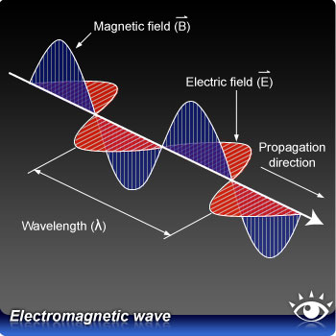

8
What is the purpose of twisting pairs of conductors together in twisted pair cable?

To minimise interference. (see lecture notes)
Shielded cables is better, but more expensive

9
What special precautions are to be taken when installing and deploying fibre optic cable?

Avoid very tight bends (may break internal reflection requirements)
If the fibre is tested with a laser, make sure you are wearing appropriate eye protection

10
How does destructive and constructive interference affect radio wave reception?

If we have a radio wave emanating from a source, reflections in the transmission path will occur and cause the wave to be reflected back, possibly to meet reflections from other parts of the wave.
Consider an alternating signal with positive and negative peaks.
Constructive: Where peaks coincide from these reflections, they can sum together to form reinforced peaks (usually a good strong signal).
Destructive: If a positive peak from one direction meets a negative peak from another reflection, we are likely to get cancellations, resulting in a weaker signal.
Exactly how this affects reception depends on the frequencies (i.e. wavelengths) being used, the position of the receiver in relation to the transmitter (remember f = V/ λ, etc). So a cancelation at one frequency may be a reinforcement at a slightly higher or lower frequency.
OR … at a particular frequency, we may get a cancellation in one location, but a reinforcement in another location just a meter or so away.

